Ferry Boats
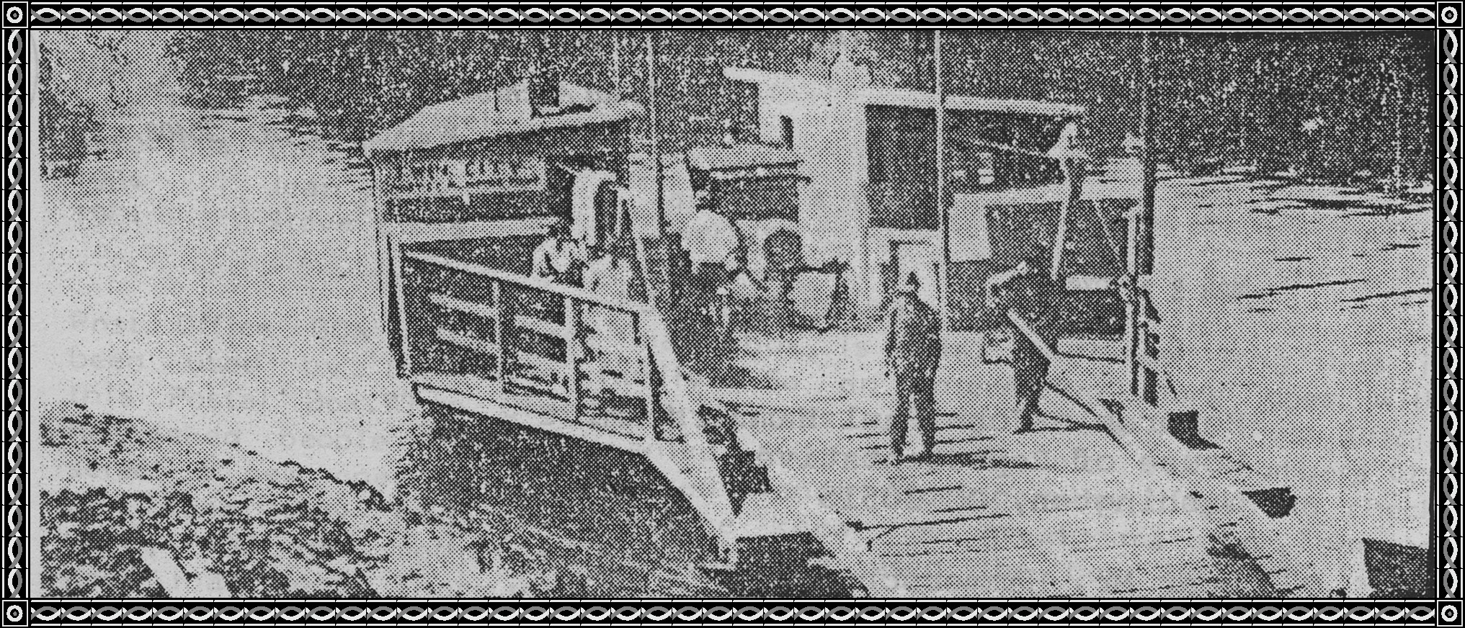
Wednesday, March 26, 1975 - Southwest Times Record
Page From History
Ferryboats like the Twin City at Ozark once were the chief means of crossing the Arkansas River. The Twin City connected Ozark and Webb City to the south. W. A. Sossamon and Charley Miller were the last operators of the ferry which went out of existence when the highway bridge opened in 1931. It then operated at Barling for a time before it sprang a leak and sank. Note the Model-T Ford between the lounge and engine room.
March 6, 1975
In today's Southwest Times Record there appeared this picture of a Ferry Boat which remind me of the one that Dick Leakey had down at the Dyer crossing over to Arbuckle Island, but I know this is not that Ferry Boat because in a new item I found this article:
July 3, 1931
Arbuckle Island Ferry Boat Burns And Sinks.
Crawford County Officers are investigating the burning of Dick Leakey's Ferry Boat of Arbuckle Island at midnight, Tuesday night. Sometime during the evening the Ferry anchored on the North side of the Arkansas River, near Dyer, caught fire. It burned to the water's edge and sank. Deputy Sherriff W. S. Bushmiaer went to the home of Leakey about midnight to investigate the burning. He said the boat had been saturated with kerosene and evidence showed it was set afire. The Ferry was operated between Dyer bottoms and Arbuckle island and was anchored near the mouth of Big Creek.
People crossed the River in wagon, on horses, or walking to come into Dyer to trade or on the way to Fort Smith. Once the Ferry was the means of travel for many people.
Early Day Settlers
After 1828 when the Indians were removed, white pioneers overflowed the region. General Jesse Miller was one of the first to return in1829-1830. He was elected sheriff in 1833 and elected to represent the County at the Territorial Legislature in 1835. He went to the State Senate in 1852, and he married Amanda Whitson.
Mark and Mary Wagner, James and Martha Heard, George and Annie Hamm Russell came in an ox wagon from Perry County, Tennessee, in 1830.They built the first homes in Mulberry in 1832.
AUGUST 28,1903
Pioneers of Crawford County had a great time in Van Buren. This was the first such meeting. Officers were elected to serve the next year which will be an annual event. Crawford County is among the oldest settled Counties of the State. Visitors who registered exceeded the expectation.
Date for the next meeting will be the third Wednesday of August each year at Van Buren. Among the oldest residents of the County were M. H. W. Wagner born in Crawford County, age 63, and a resident still of Crawford County; and 63 years old Benjamin Dyer born in Tennessee age 71, a resident for 71 years as he came here as a baby.
The John Moss Hotel
Built in 1886. Teachers and Drummers stayed at the Hotel.
This was also the home of Harve Chastain, Shibleys, Carrolls; Thad Johnson lived in this house the longest of anyone. Ernest Cottrell razed the house and built a new one on this spot.
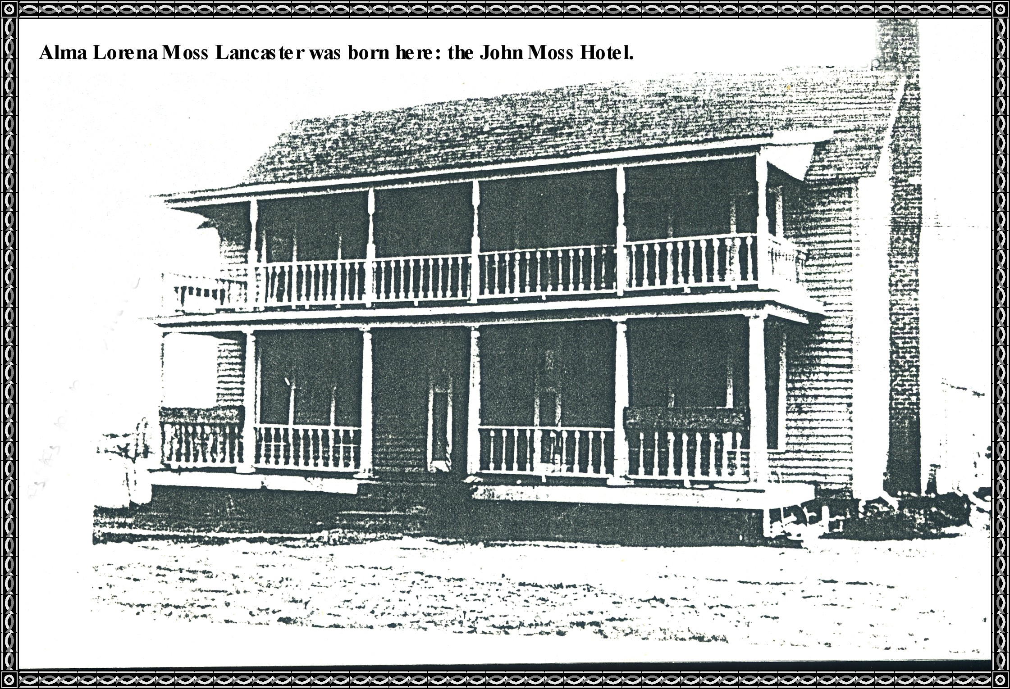

Bank of Dyer
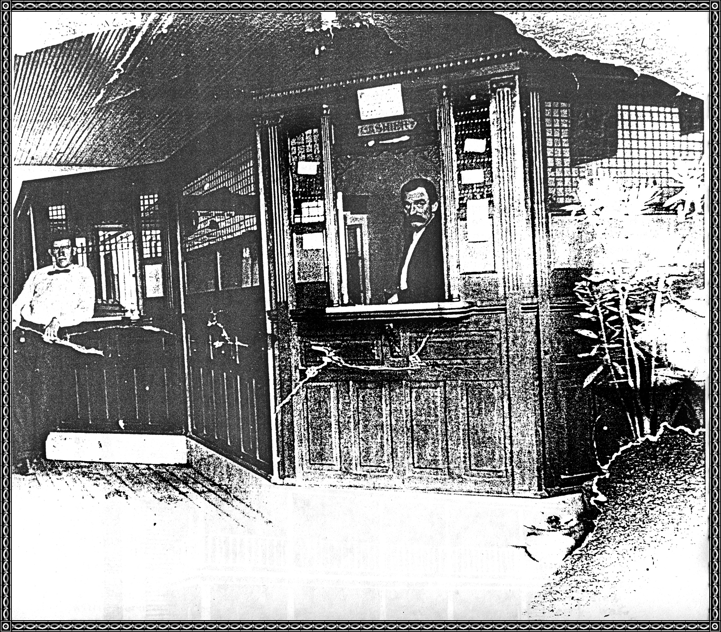
The Bank of Dyer was built in 1909 with David T. Bryan established the bank and Henry Burrough was Cashier. Later Walter Patton at left of picture was assistant cashier and Henry A. Burrough is at the right of picture.
Data From Bonnie Rhea Henson Wright
My great-grandfather, BERRY ROE, once owned the land from the North City limits of Dyer to the railroad, North and South, East and West from the line in front of Mother's on Washington Street just North of Highway 64, over to the next road, North and South, by Claude Hatleys.
My grandpa, Will Roe, his brothers, John and Alonzo Roe, and my Grandmother Henson's brother, Jim Moseley, cleared that area.
Telephone Exchange
Operated By Joe Jean
