1884, USPS Location Paper
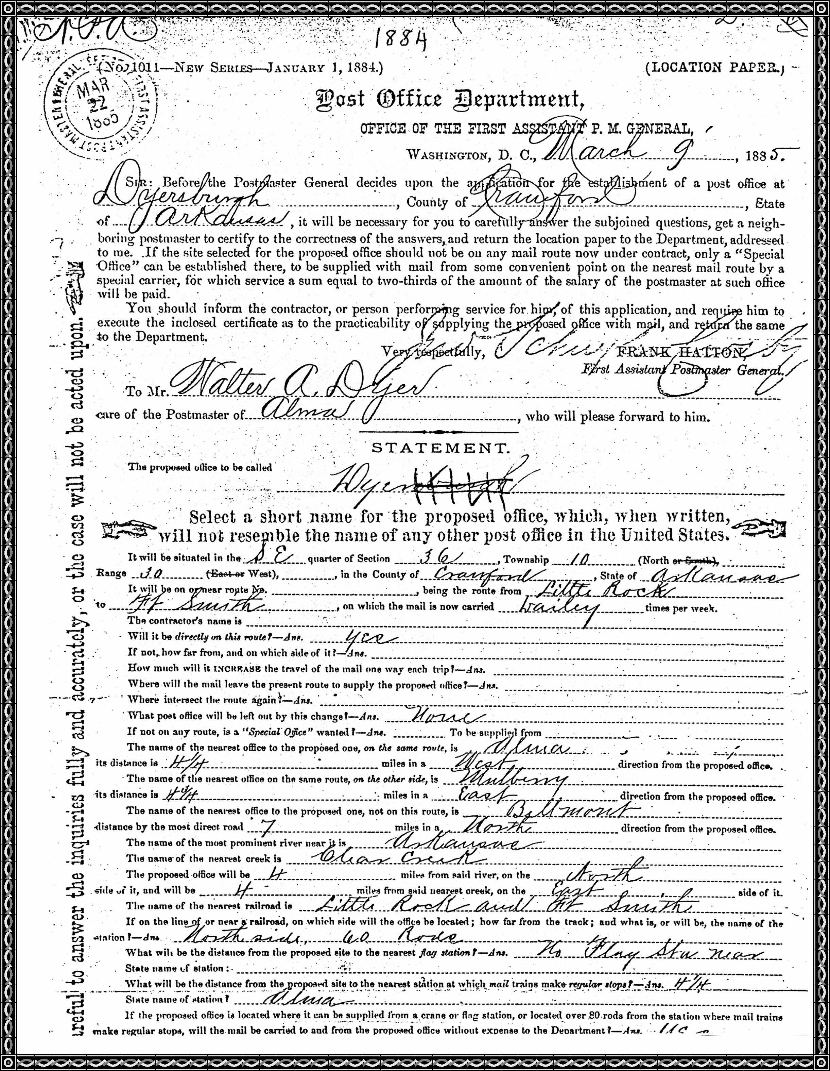
September 4, 1980
Arkansas Valley Times
After Forty Years Service, Dyer Postmaster Retires
By Teresa Ellington  Since 1940, Dyer Postmaster Clay Cottrell has probably sorted over 600 thousand bundles of mail.  Cottrell's last day at the post office was Friday, Aug. 19. He is retiring after a remarkable 40 years of service.  The Dyer native said the biggest change in 40 years was from 35 post office boxes in the 1940s to 190 in 1980.  In 1976, district headquarters in Fort Smith decided to get Dyer a new post office building. The old one was a store building with practically no modern con-veniences.  Cottrell said the district office has always been "cooperative with Dyer."  While Cottrell was in the armed forces, he dispatched mail in Central England at a town "not much bigger than Van Buren."  When he got out of the service, Cottrell said "jobs were scarce." He worked at the Dyer post office during James Farley's admin-istration. One of his main duties was to hang mail on an "arm" near the railroad track so the train could pick it up.  On May 30, 1940, Cottrell became the Dyer Postmaster. His duties included: handling general delivery mail, money orders, sorting outgoing mail, dispatching mail and insuring and handling registered mail. | "It’s a one-man performance," Cottrell said.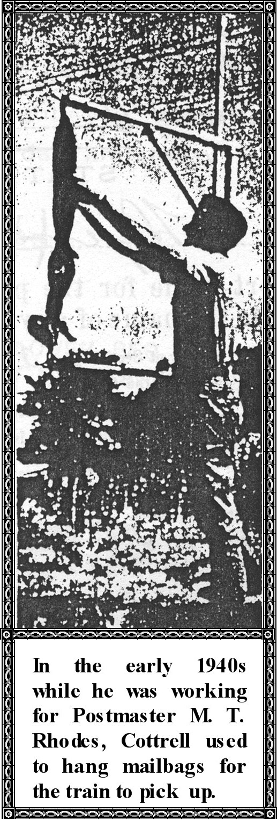  When he is not in the office, his wife, Mildred, manages the | operation. She has worked as a postal clerk 35 years and has no plans for retirement.  Cottrell said the busiest time at the post office is during the Christmas holiday.  "We're busy all the time," he said.  Cottrell works from 8 a.m. to 12 noon. then from 1 p.m. to 5 p.m. He said he has "breathing periods." Cottrell is busy first thing in the morning until close to 11 a.m. Then there is time to "catch up" before the noon crowd. The afternoon allows Cottrell to take care of sorting mail and other duties until "the after work crowd comes in."  Cottrell said he likes to garden and "do a little fishing" in his spare time.  "I'm going to do things I never had time to do," Cottrell said.  He regrets leaving his position because he knows his customers and will miss them.  He and his wife have two children. Gary is an attorney in Van Buren and Gayla, who works at Crawford County Hospital and resides in Dyer.  The Cottrell's have two grandchildren.  Cottrell will be replaced by Steve Loris of Fort Smith. Loris will be the OIC (officer in charge) until another postmaster is established. Loris was previously in Van Buren at the city post office.

September 4, 1980
Arkansas Valley Times
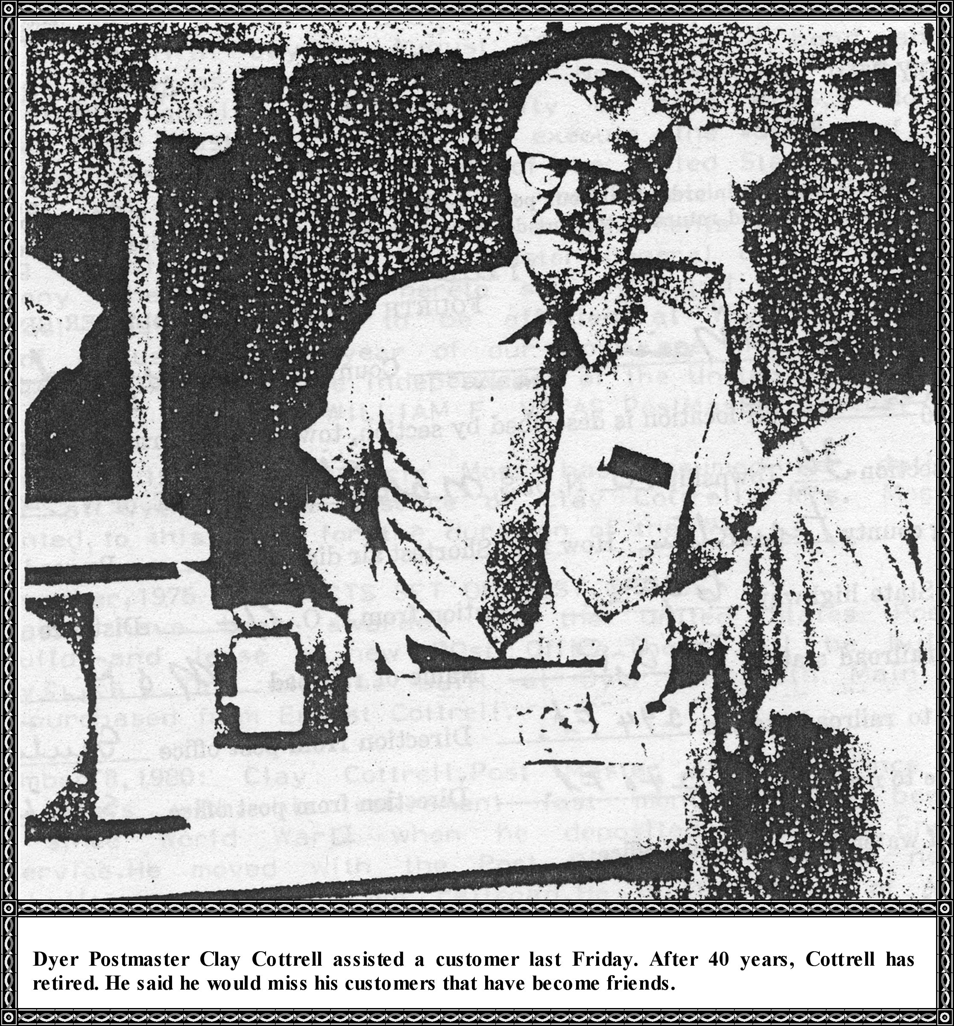

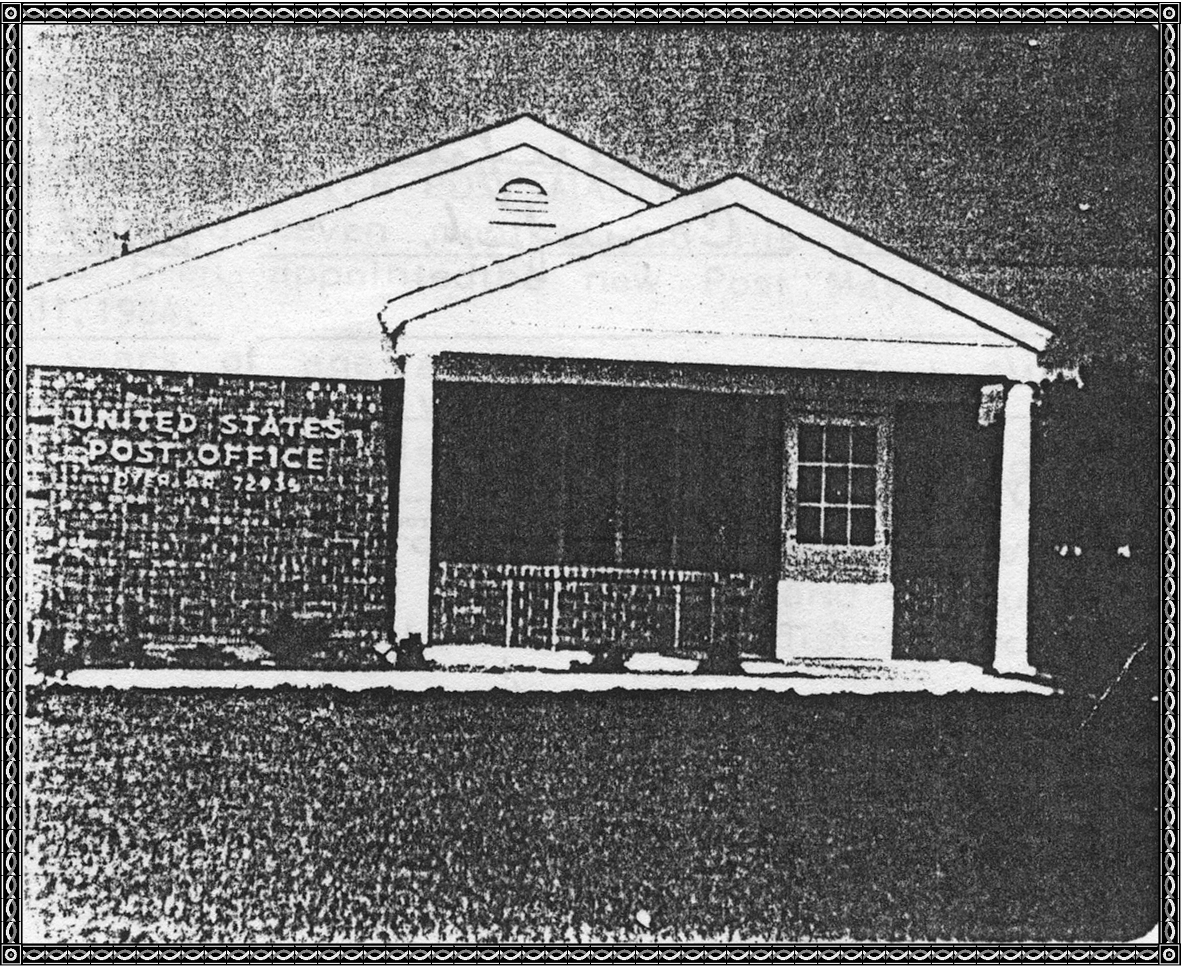United States Post Office, Dyer, Crawford County, Arkansas
Erected in 1976

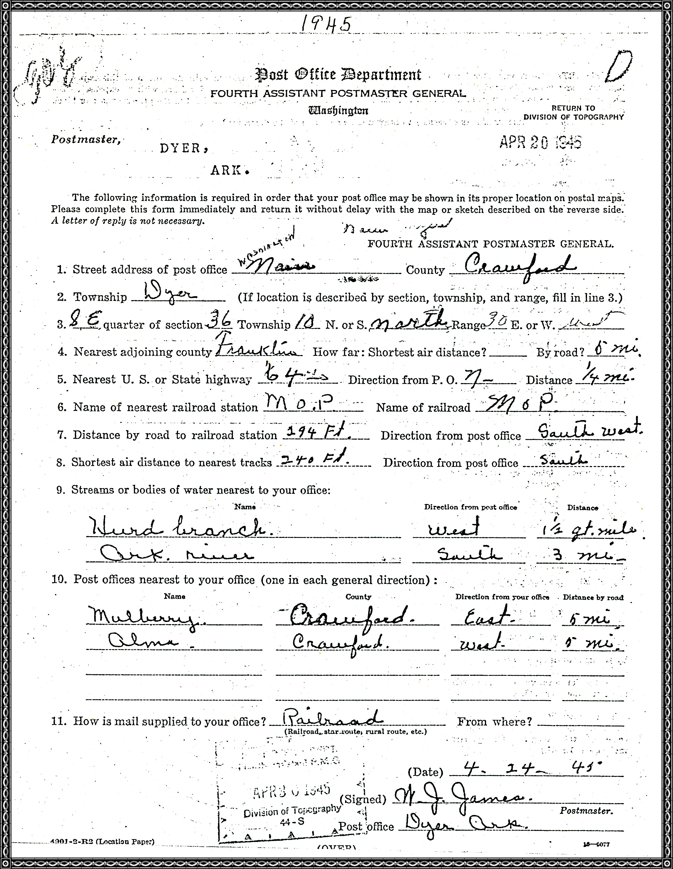
1886: Post Master General Of The United States Of America To All To Whom These Present Shall Come Greetings:
Whereas on the 31 day of July 1886, JOHN WM.MOSS, was appointed Post Master at Dyer in Crawford County of Arkansas. And whereas he did the fifth day of August 1886 execute a bond and has taken oath of office as required by law. Now know ye that confiding in the integrity, ability, and punctuality of said MOSS, I do commission him a Post Master, authorized to execute the duties of that office at Dyer, aforesaid, according to law of the United States of the regulations of the Post Office Department. "To hold said office of Post Master with all the powers, privileges, and inducements to the same belonging during the pleasure of the Post Master General of the United States. In testimony whereof I have hereto set my hand and caused the seal of Post Master at Dyer to be affixed at Washington City this 12 day of August in the year of our Lord one thousand eight hundred and eighty six and of the independence of the United States."
WILLIAM F. VITAS Post Master General
September 18, 1942: Mrs. Guthrie Moss has assumed her duties as Post Master at Dyer in the absence of Clay Cottrell. Mrs. Moss has been appointed to this place for the duration of the War.
24 November 1975 CONTRACTS SET ON POST OFFICE
Contracts have been awarded by the United States Postal service to build and lease a new Post Office. These will be built in three townships. One will be built at Dyer on South Main Street, the land purchased from Ernest Cottrell.
September 8, 1980: Clay Cottrell, Post Master of Dyer since 1940, ended forty years with his retirement last month. He has been handling mail since World War II when he deposited mail in England while in service. He moved with the Post Office 1976 to the new one that was built on South side of railroad. He is the father of Attorney Gary Cottrell and Gayla Cottrell Milsap, a daughter.
October 29, 1983: Loy Cottrell's daughter-in-law will serve as Post Master on Saturday mornings. Mildred Cottrell retired after 38 years in the Post Office.
January 5, 1984, Jean Stratton retired from the Post Office at Dyer.
April 14, 1984: Loris Named Dyer Post Master.
Loris has been married seven months, and his wife's name is Vickie. Stephen Loris has been appointed the new Post Master at Dyer, effective Saturday, March 31, 1984.
Loris is 33 years of age and a native of Fort Smith and began his Postal career in 1975 at Van Buren Post Office as a city carrier and distribution clerk. He also worked at Hot Springs. He moved to Dyer to be near his work.
Steve Loris was born March 2, 1951, and married Vickie Hecke at Hot Springs. He attended school at Northside and graduated in 1969. A member of the Midland Height United Methodist Church, he married on 26 October 1983.
Our Post Masters since 1940 have been:
1940-1980: Clay Cottrell
1980-1984: Gene Stratton
1984: Jean Hollander January 4 through April 13
1984: Steve Loris April 14
Post Office Box
Post Office Box 141 whose mail box is this? And how long has it been used by the same family? So an interesting story goes with this Postal Box. When Clay Cottrell was moving to the new Post Office he asked people if they wanted to keep their old box numbers or select a new one. W/hen he asked Wanda Aldridge, they began to check how long they had used 141.She knew her great-grandfather, Thurman Hurd, and her mother Ruth Hurd, had used the box 141. The story goes that Uncle Thurman Hurd had rented Box 141 when he first came to Dyer in the late 1800's and four generations had removed mail from Box 141. He had taken letters from his two sons, Richard and Fred Hurd, when they were in Europe fighting for our freedom during World War I .He had also taken the letter out of Box 141 when he received the word that Richard Hurd had died in a hospital in Kentucky and the body would arrive home to be buried in the Dyer Cemetery.
My father, Thomas William Moss, always used P. O. Box #40 until we moved to Kansas City and when we came back in about a year we used 70, but as soon as Daddy could get #40, he rented it again and used it until he died and Mother used it until she went to live with us in 1968. I never could understand why as this was a very inconvenient box as you had to ask the Post Master to hand you the mail.
There are probably other Post Office boxes with interesting stories but no one has handed them to me.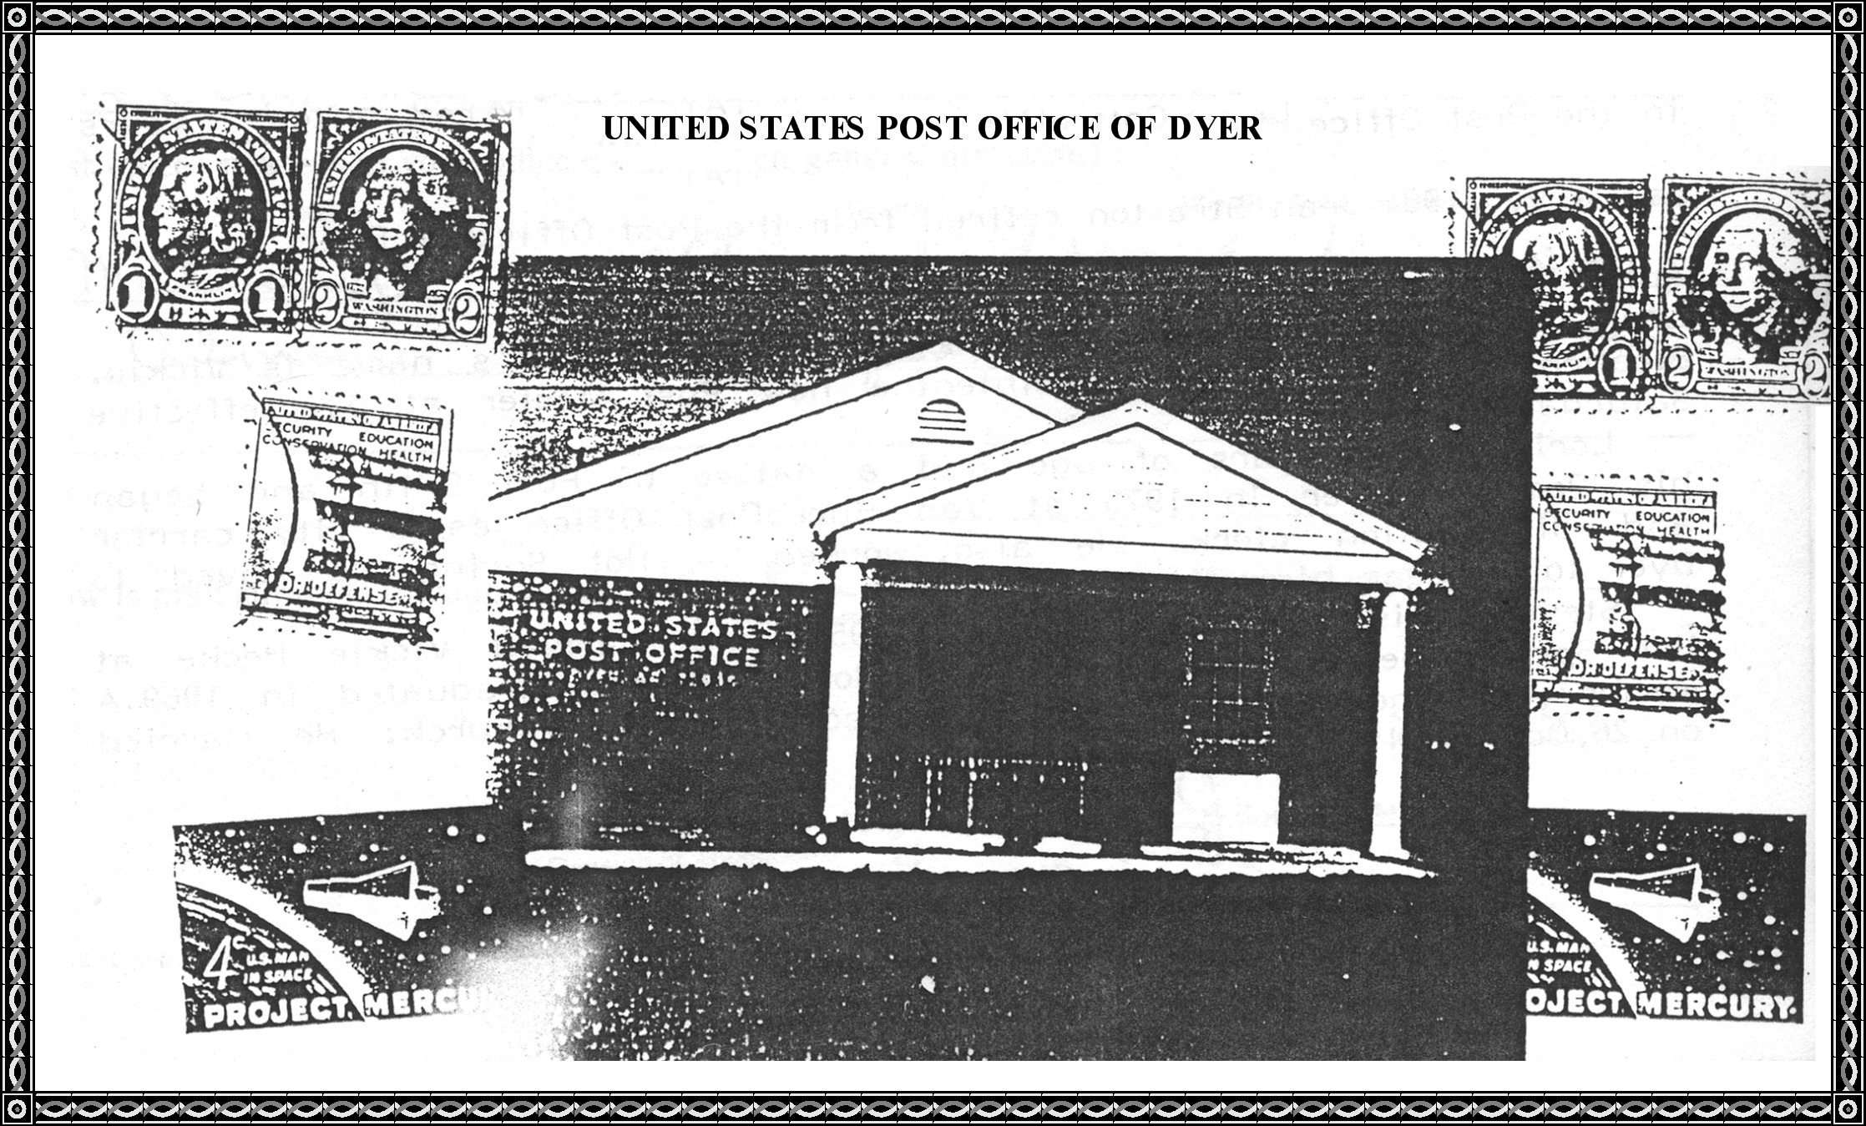
UNITED STATES OF AMERICA
GENERAL SERVICES ADMINISTRATION
National Archives and Records Service
Washington, DC 20408

May 22, 1976

Honorable John Paul Hammerschmidt
House of Representatives
Washington, DC 20515
Dear Mr. Hammerschmidt:
In a telephone call on March 17, 1976, Miss Betsy Sandza of your staff requested, on behalf of Mrs. Irl Lancaster, information about the post office at Dyer, Crawford County, Arkansas.
The records of the Post Office Department in the National Archives show that a post office was established at Dyer on July 20, 1885, The names of the postmasters who served at this office and their dates of appointment through September 30, 1971, are as follows:

Walter A. Dyer  John W. Moss  Tilghman M. Layton  Robert N. Anderson  John S. Chastain  Stephen M. Dyer  John S. Chastain  Marion T. Rhodes  Hiram M. Bennett  William C. Creekmore  Walter D. Patton  Kate Rogers  Marion T. Rhodes  H. Clay Cottrell  Mrs. Lucille Moss  William J. James  H. Clay Cottrell | July 20, 1885  July 31, 1886  June 20, 1887  June 07, 1888  June 15, 1889  June 29, 1893  January 08, 1898  April 07, 1904  July 19, 1918  January 03, 1919  February 14, 1921  July 08, 1921  September 09, 1921  June 01, 1940 (assumed charge)  June 05, 1940 (acting)  November 04, 1940 (confirmed)  September 08, 1942 (assumed charge)  October 01, 1942 (acting)  December 12, 1943 (assumed charge)  December 28, 1943 (acting)  February 14, 1946  (Returned to duty from Military leave)

Keep Freedom in Your Future With U.S. Savings Bonds

