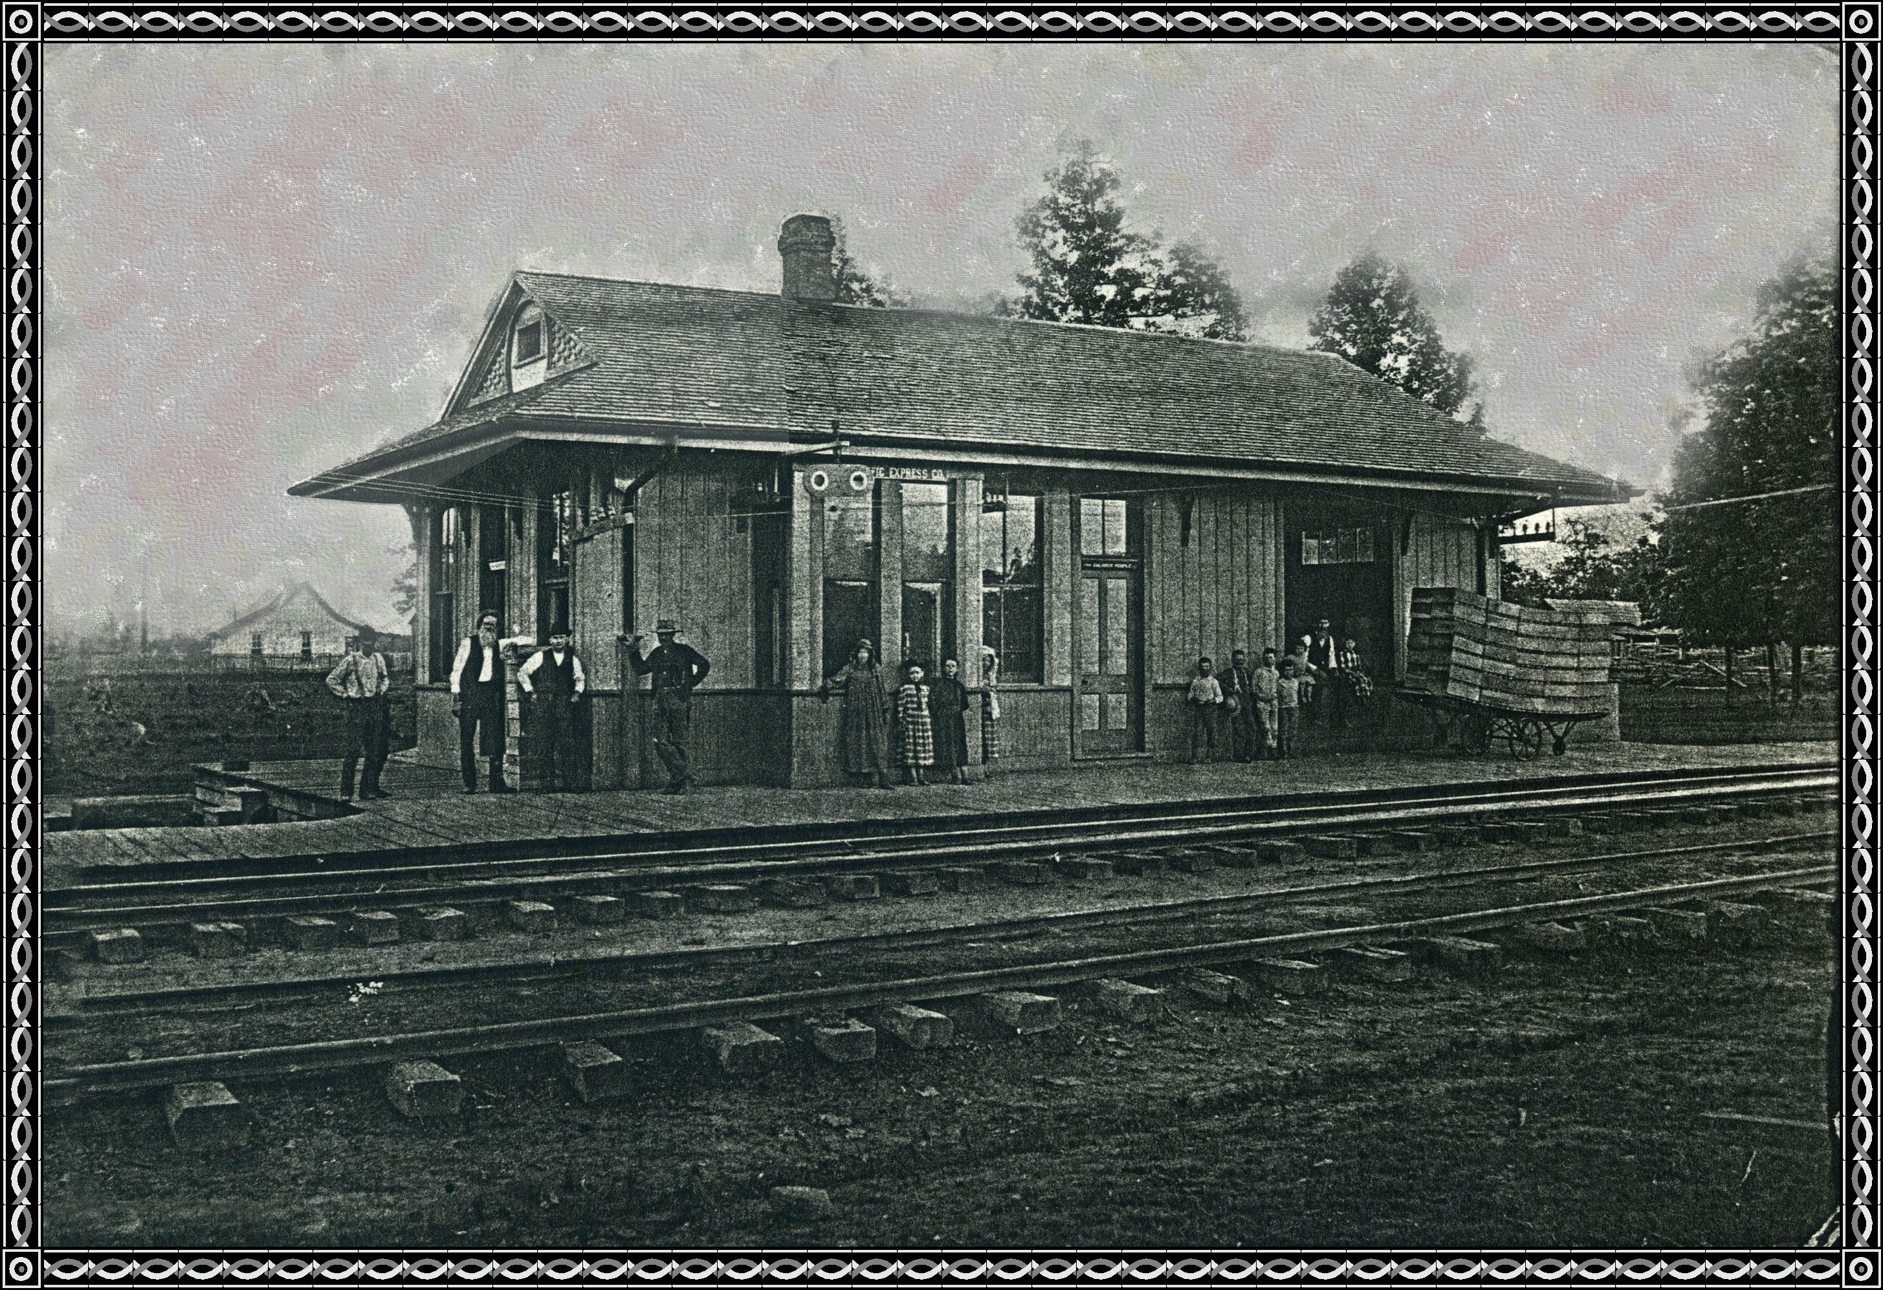
Nellie Dyer, a missionary and my cousin, sent me this picture and said Uncle Elisha, her father, said this was a picture of the Dyer Depot. Mrs. Florence Bennett didn't think so, but take that picture and put it beside the one we all remember, and they look a lot a like. Could it have been the one at the West crossing and later moved to the East crossing? Look at the house in background and the Depot covers the old Moss Hotel.
THE BLACKSMITH SHOP
"Under the spreading chestnut tree, the mighty Smithy stands."
This was a man's world. One place that women did not venture in. no more do we see the Smithy working the bellows to build the fire or beating upon the materials on the anvil. But who of us has not stood in the doorway and watched the blacksmith swing his hammer and shoe a horse and wonder if driving in the nails did not hurt the horse or watch him fire the anvil. This shop was a necessity in yesteryears for here the farmers tools were sharpened and repaired and the horses shod. And this was also another corner for men to have their gossip sessions.
THF ICE HOUSE
There was a ice house on the corner of Washington and Alma Streets. Sawdust was placed inside the little house so that the ice would not melt so fast. One would buy from 25 to 100 pounds at a time to have cold lemonade or to make ice cream on the fourth of July.

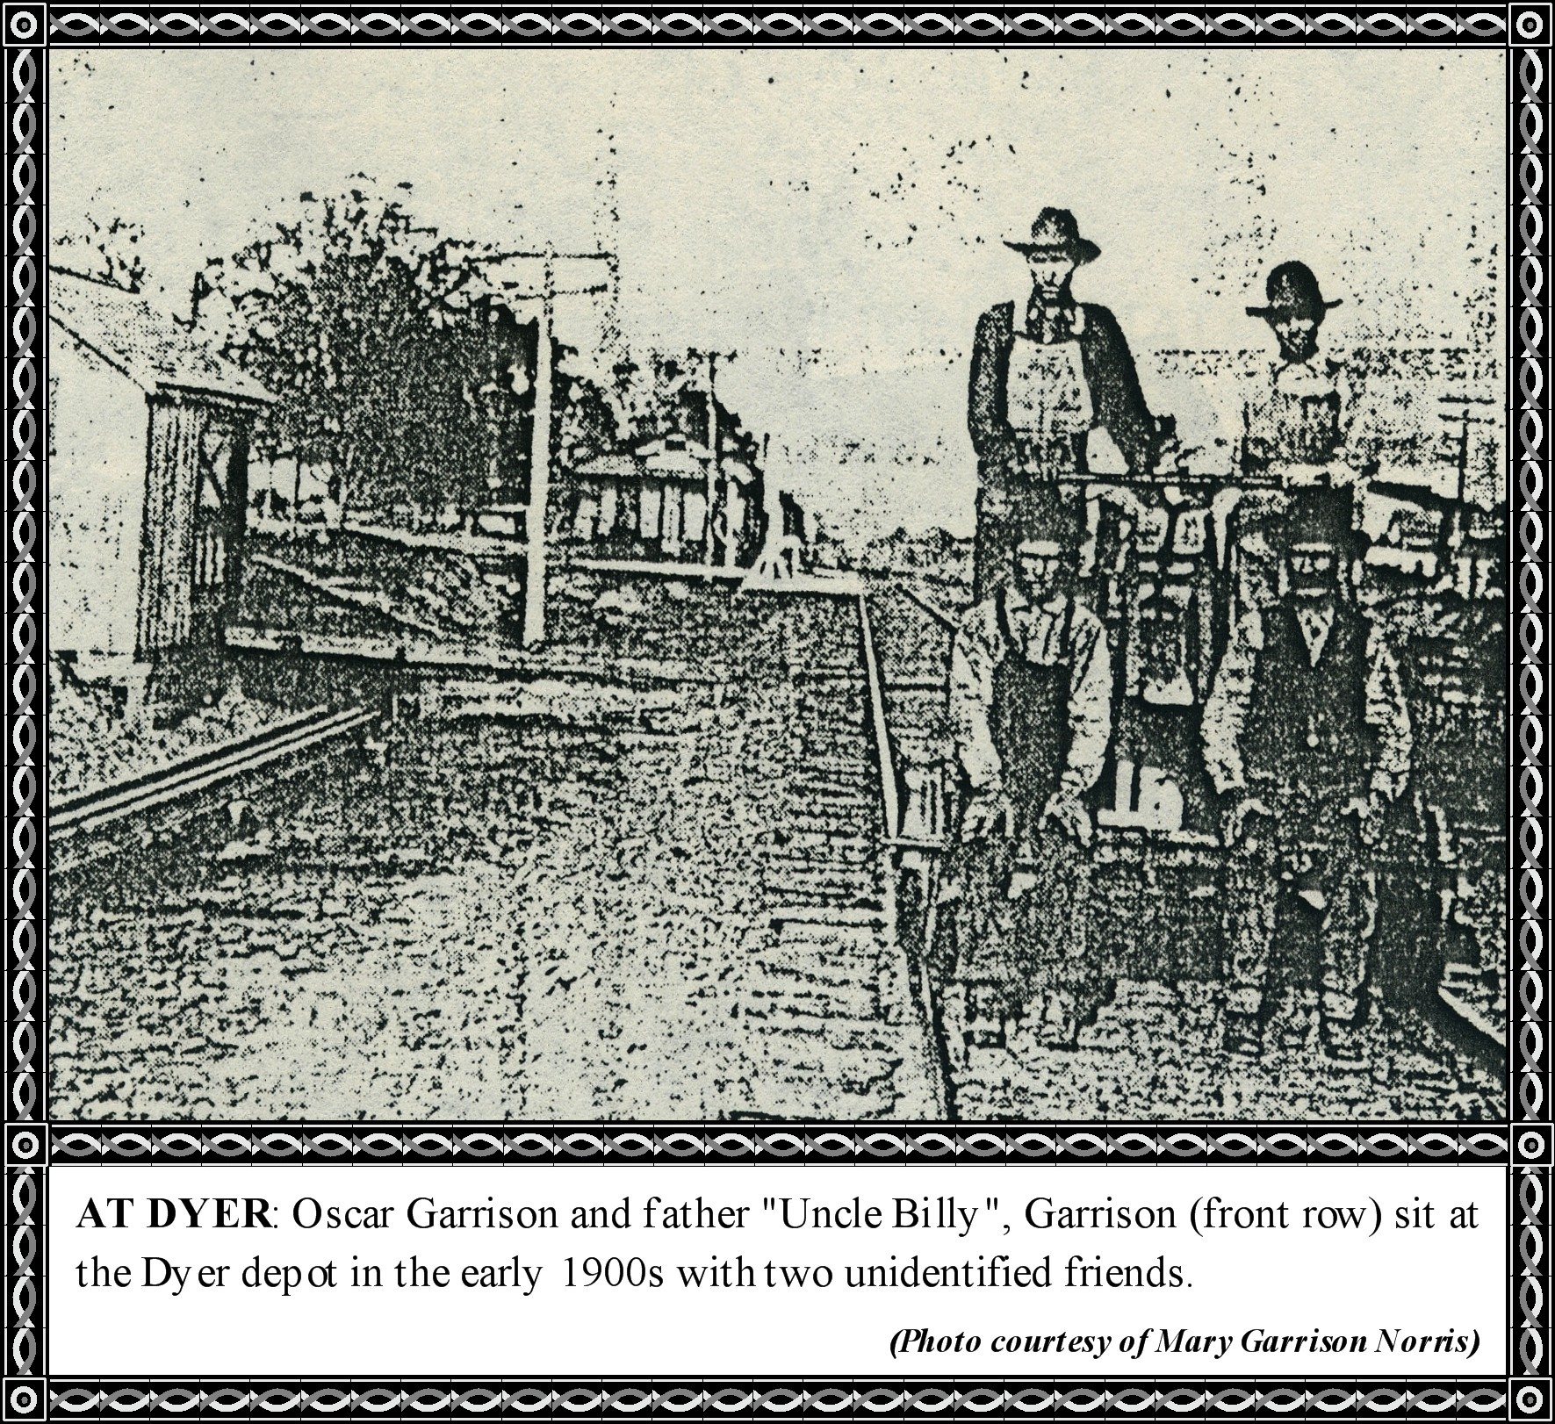
I have done a lot of research on the Depot and the Post Office. I finally received a list of all Post Masters that served Dyer from 1885 to date.
Then from the St Louis Iron Mountain and Southern Railway I received the following plats of the first Depot, drawing of the floor plan for the first Depot. The second Depot, the shipping Shed, and main part of town.
I have run off copies of these so you might be able to place the railway buildings.
The land where Dyer is located was purchased from the Railway Company in 1880 by Stephen Dyer.
From 1876 until 1887 Dyer had no Depot and was a "Whistle Stop," meaning that the train was flagged down if there were passengers to board.
In 1887, Mr. Loomis built the first Depot. The materials were donated by George and Stephen Dyer and John William Moss. The Depot was located at the West crossing on the South side of the railway, facing North. Cyrus and Charlie Dyer were the first agents. This Depot burned. Then the Railway Company rebuilt a Depot in the same location as the stores of the Town—faced the railway, and Main Street was the main part of town.
Sometime the Station was moved to the Fast crossing and it looks as though it was added to when moved. As you can see by the drawing the first station built by the Company had an office, with a waiting room just behind the office, and the freight room on the West side of the Depot with a platform running across the west side and down the South side of the Depot..
I was sent a picture by Nellie Dyer who said that her father told her this was the Dyer Depot. Several said no, it was not, but looking at the drawing I believe that this is a picture of the first Depot at the West crossing.

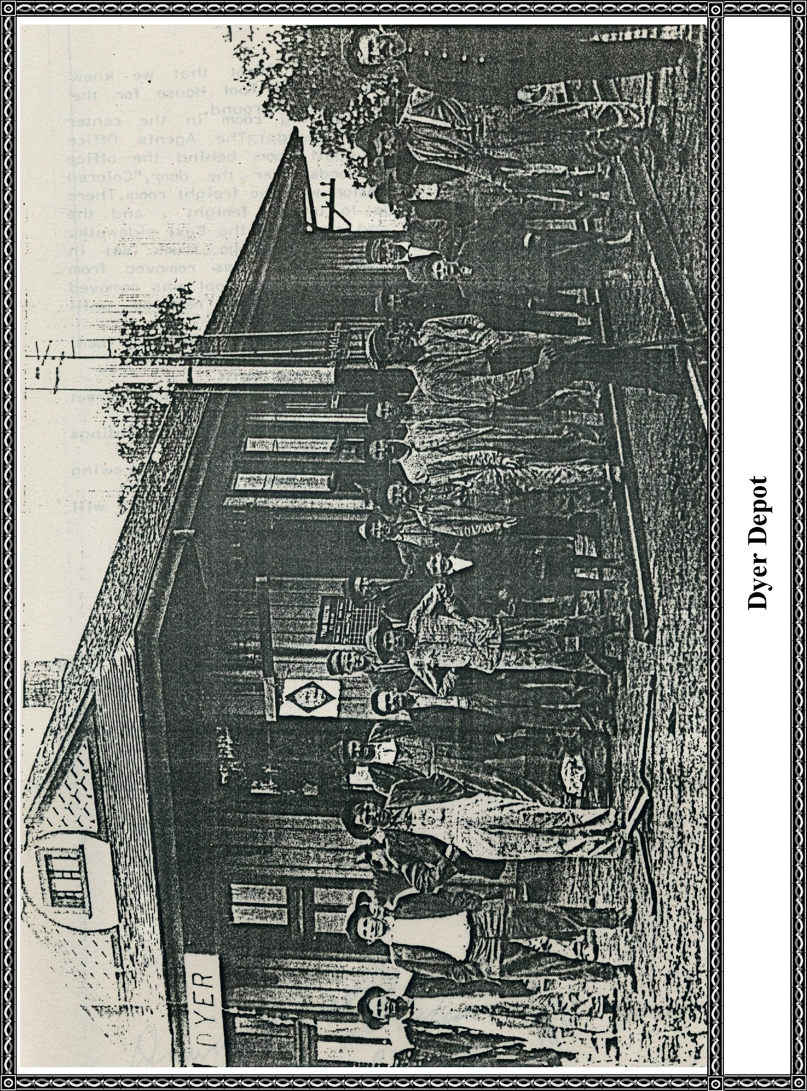
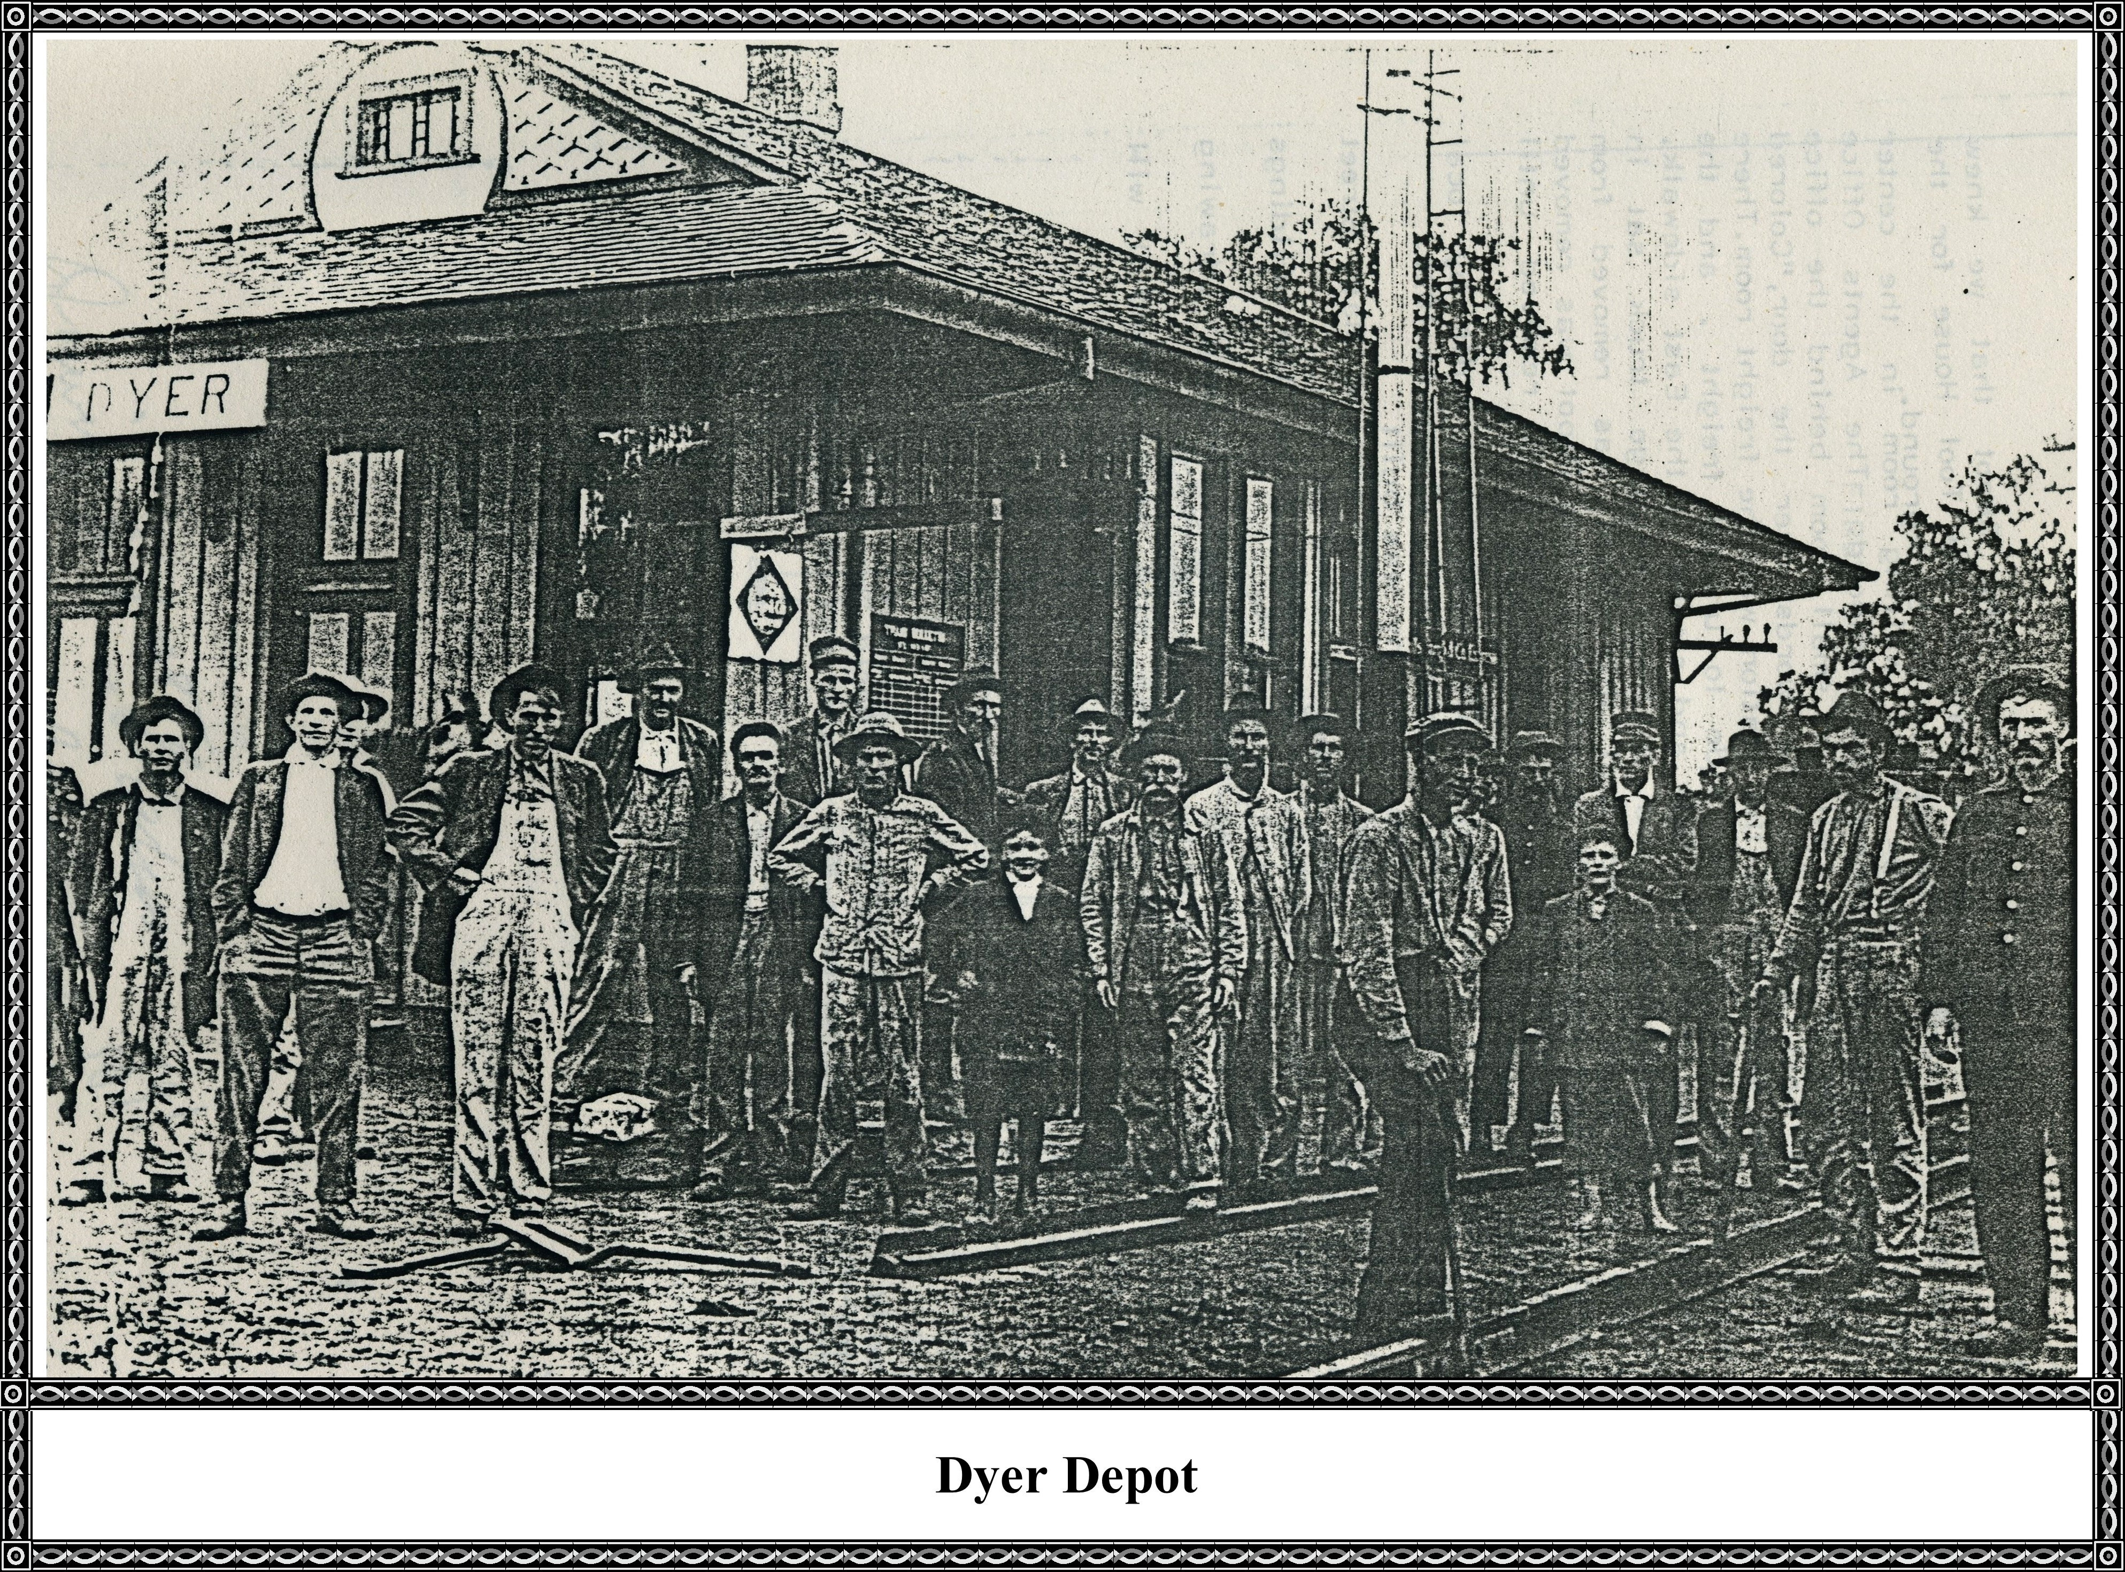

The picture on the opposite page shows the Depot that we knew behind the Handcar stopped just in front of the Tool House for the Railroad. Also, the mail crane can be seen in the background.
The second Depot had a large white waiting room in the center of the building facing North and the railroad. The Agent's Office was on the East side of Depot with a small room behind the office on the South and East side with the words over the door, "Colored
waiting room." On the West side of the station was the freight room. There was a high platform on the West side to unload freight, and the platform extended down the South side and sloped to the East sidewalk.
The depot was painted yellow and a large baggage truck sat in front of the depot (it is believed that this Depot was moved from West crossing to the East crossing in about 1910). This Depot was removed from Dyer in August 20, 1936. The Mail Crane was not removed until 19 September 1962.
Some more data that I have located: The first Depot was built by local people in 1887. This building burned. Company built a Depot in 1891. November 10, 1895, the depot by Railway Company was built.
A section house was also built and was on west side of Main Street and then moved to South side of town; have no dates on this.
In 1913 there were three buildings and a Mail Crane. The buildings were the depot, the tool shed, and an "out house."
The Berry Platform was built by the Railroad Company, drawing included, which was a 16 x 24 size built June 8, 1903.
Since I could not locate names of Agents with years served, I list those I can remember.
1887 Cyrus Dyer
1903 Thomas William Moss
1904 xxx Harroway
1906 Matt Hopper
1913 Sebe Phillips
1918 Bill McNeely
Some filled in for McNeely while he was in World War I. Other names that I recall were a Mr. Riddle and Charley Jean.

Sketch of First Dyer Station Built In 1891

Inside Sketch of First Dyer Station Built In 1891
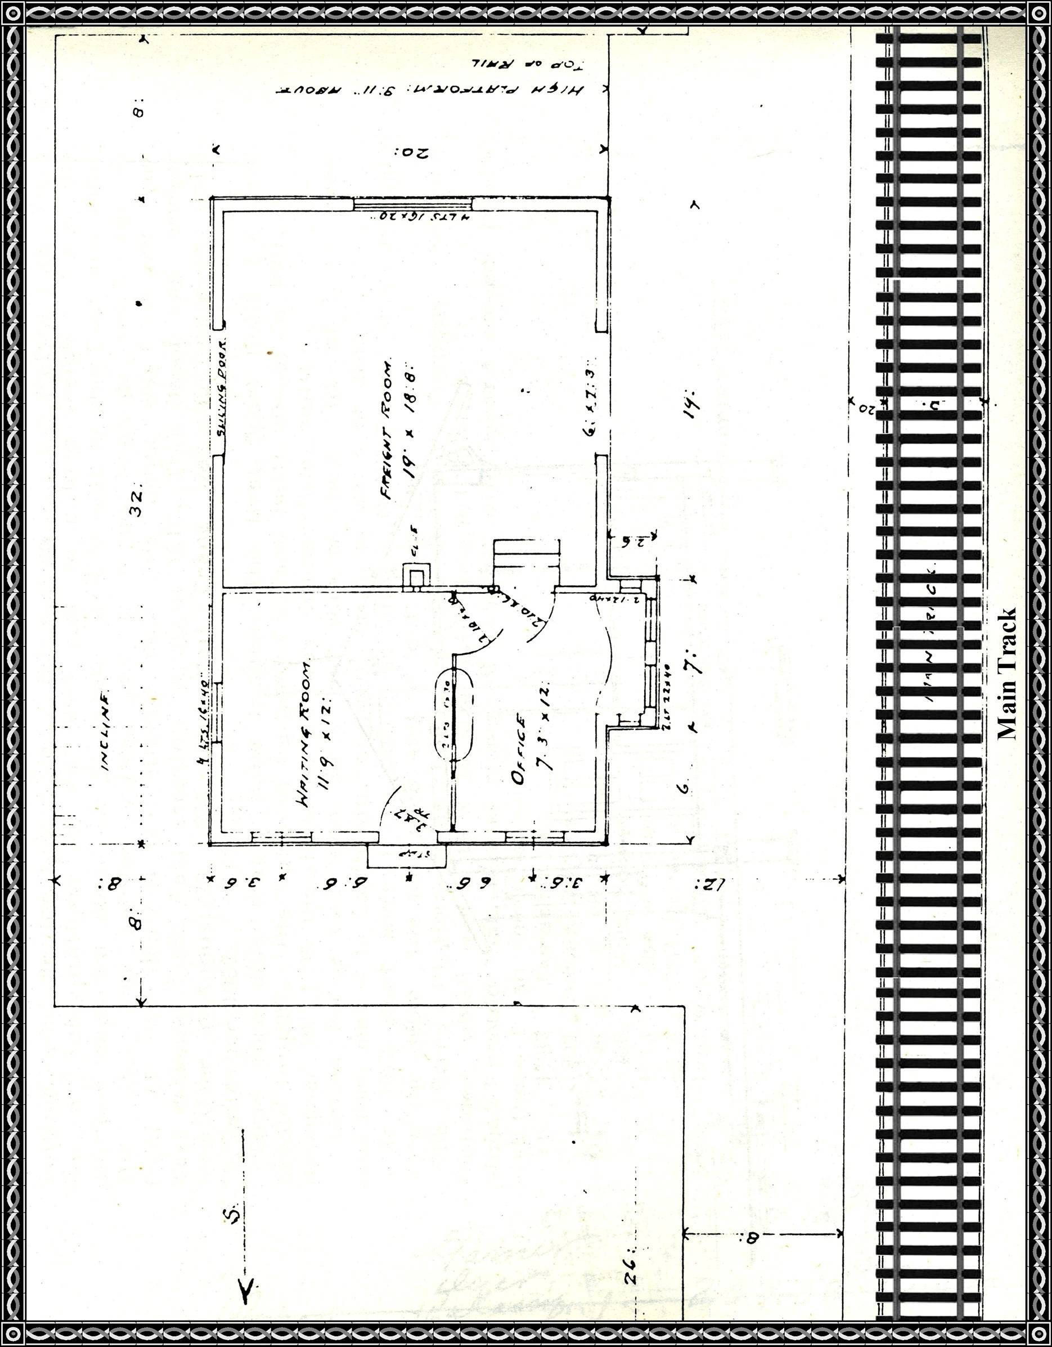

The Depot As We Remember It
[Editor's note: Unfortunately, this is a direct copy of the page in my copy of this book ~ about which I have no understanding of these data.]
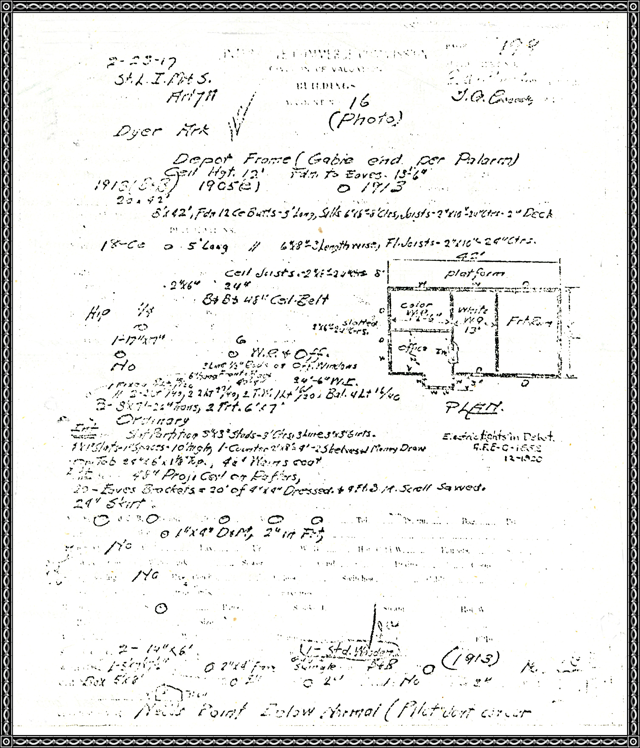

Berry Platform 16' x 24' Built At Dyer
40 feet extension to Fruit Shed: Comp. 07/03/1912
