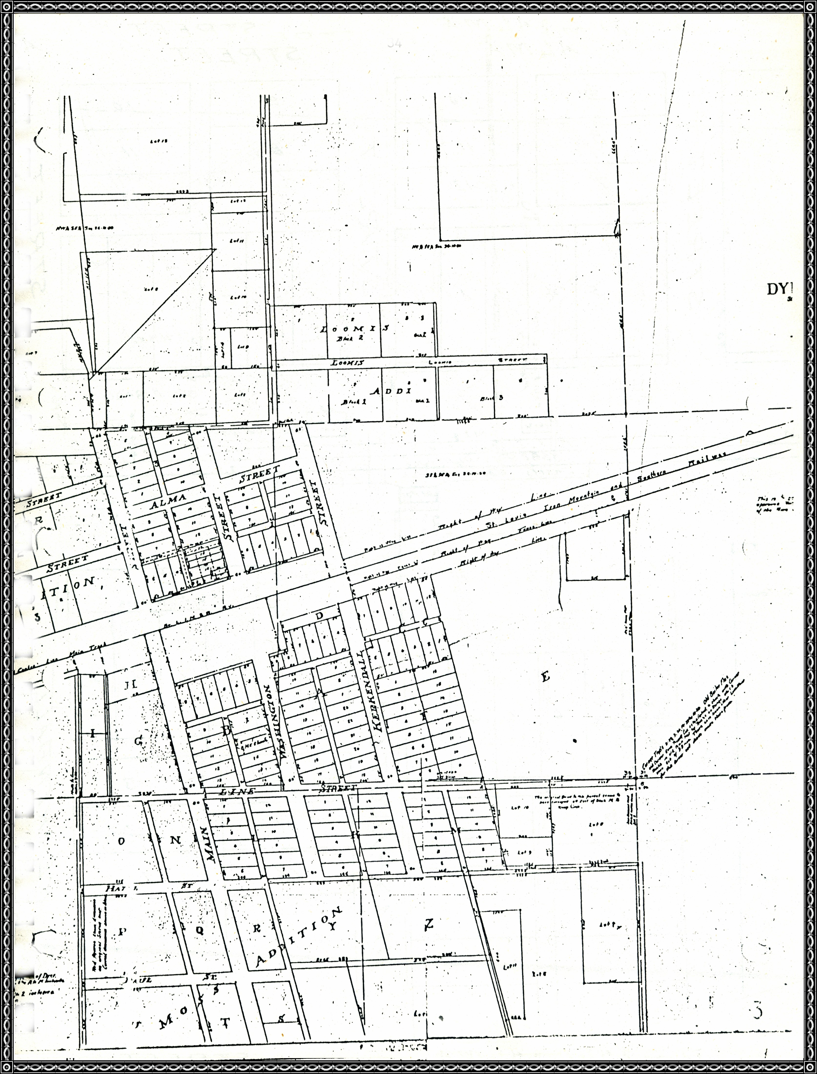Map of Dyer Streets

Map of Dyer Streets
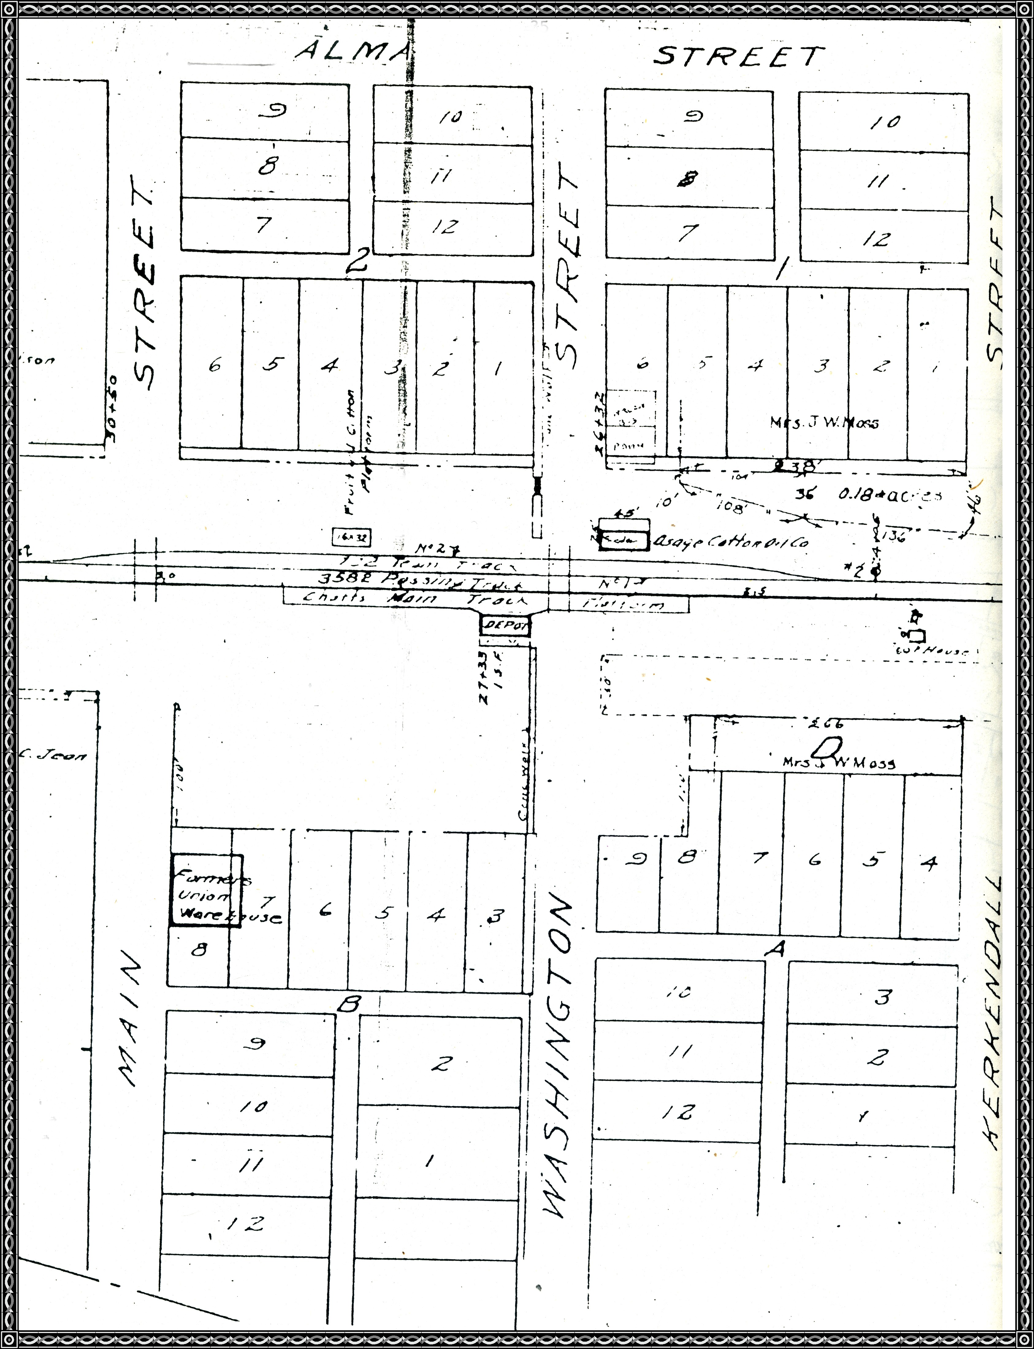

Map of Dyer Streets
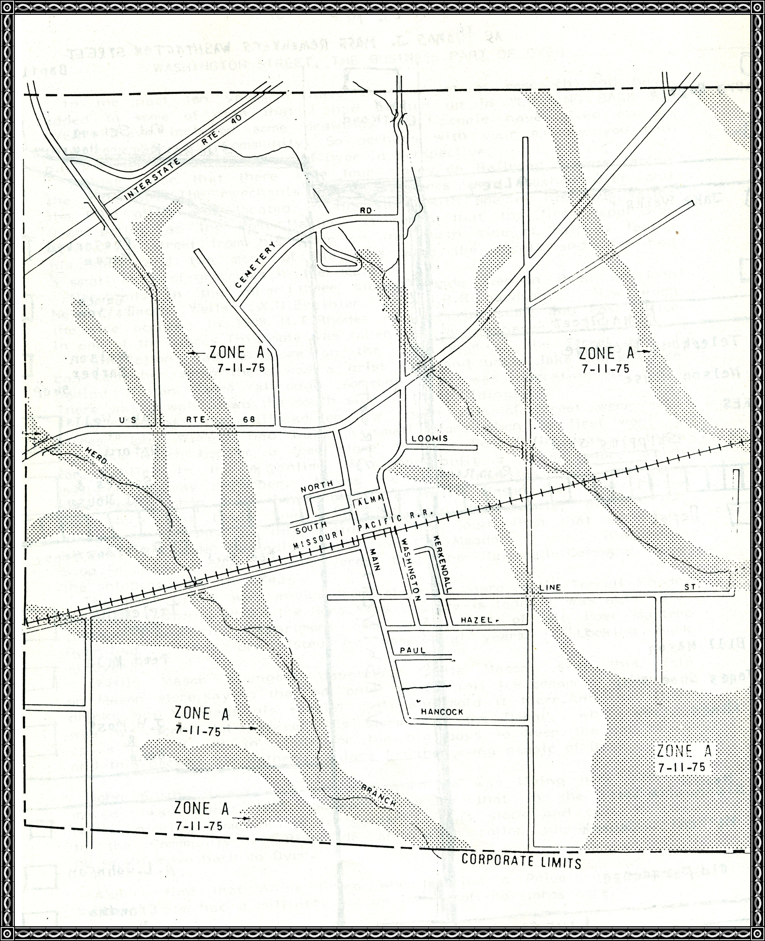

Early 1900s map of Washington Street as remembered by Thomas W. Moss
